Putokazi proudly presents "Raskružje (Circuition), Musical of change".
Libretto written by Irena Križ combines Greek and Slavic mythology composed by orchestrator and music producer Philip Frank in a recognizable sound of symphony that challenges new artistic approach of Putokazi allowing to wake the new world around and dares to bring distant stories to the surface, hidden and forgotten in its roots.

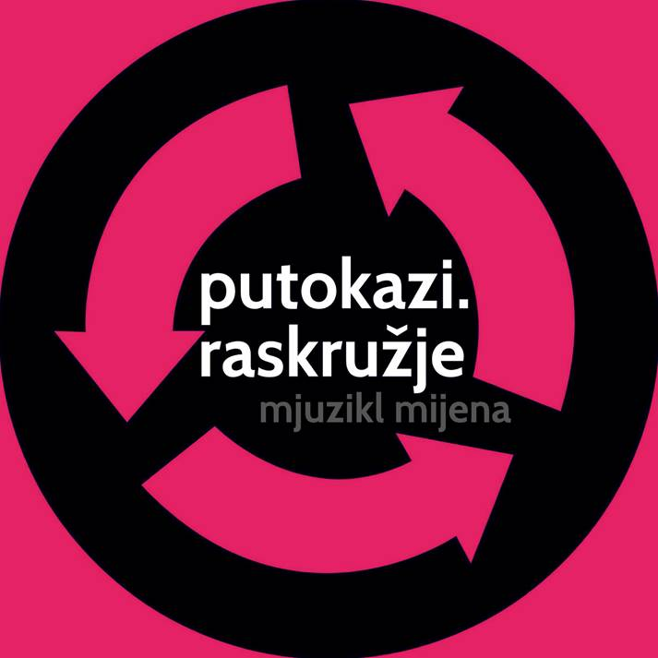

putokazi@putokazi.hr info@putokazi.hr miranda@putokazi.hr

In "Raskružje, Musical of change", Slavic myth of Jarilla and Morani intertwines with the Greek myth of Persephone. Opposing these two related mythological stories about the origin of the spring, "Raskružje, Musical of change" examines what would happen to the Persephone if her curiosity lead her voluntarily to the underworld of Hades. Would the pain and grief of her mother Demeter have felt any less if Pershepone hadn´t been kidnapped as in the original myth, but left willingly and thus "betraying" her mother´s orders.

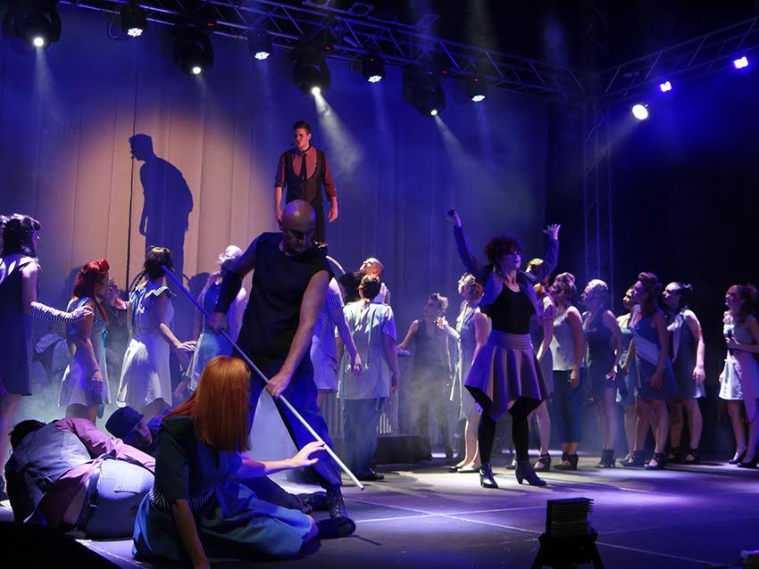

The main characters Morana / Persephone, Jarilo, Janja, Mr. Nice and Young, Demeter and Perun, fairies Rusalkas and Polunocnice (ladies of Midnight) try to preserve love, peace, respect, happiness, truth and unity. Circuition denotes traveling, a roundabout of life, in which humans enter and exit, in perpetual changes, seeking and exploring, changing and developing within ourselves. Just like Putokazi with the generations of performers, they grow constantly, recommencing afresh over and over again.

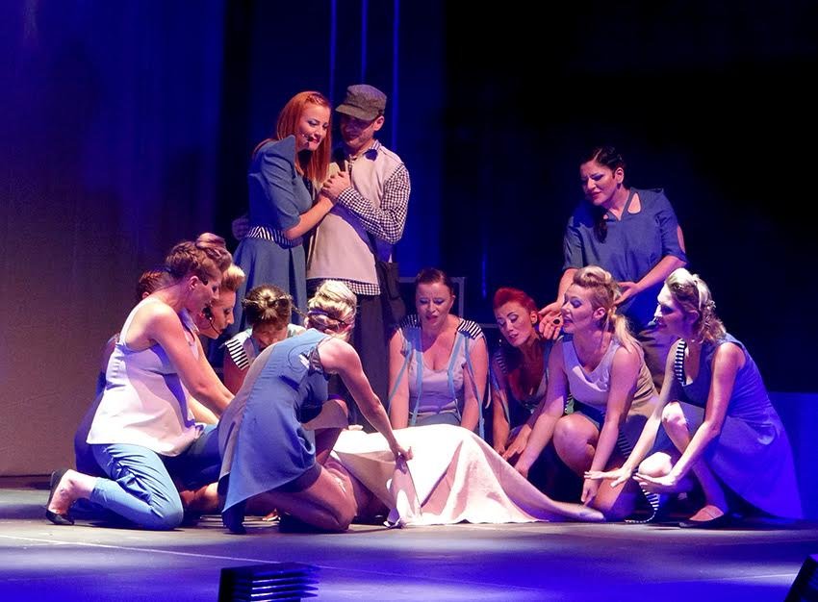

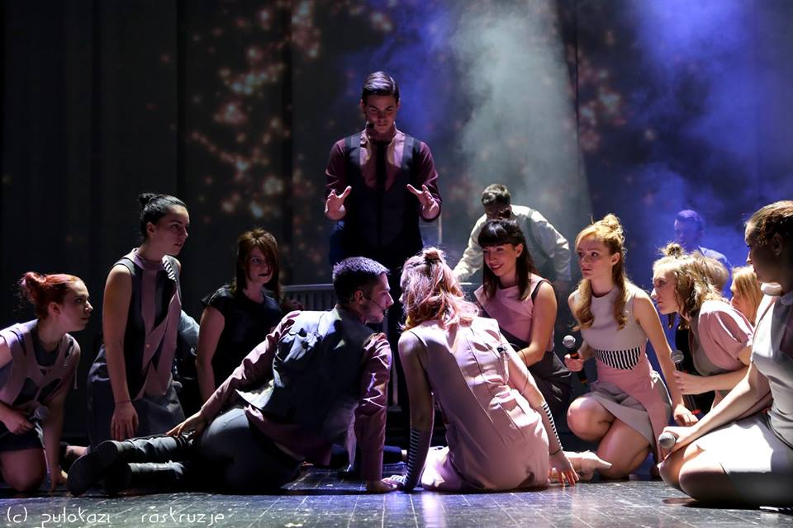

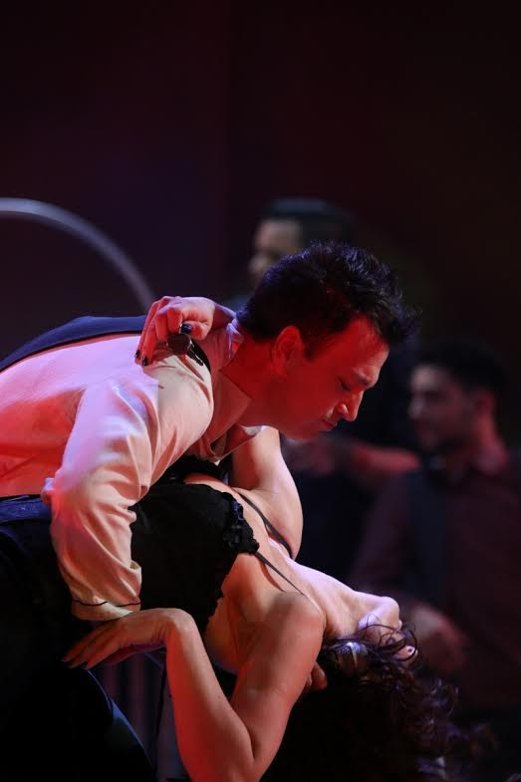

www.putokazi.hr
www.youtube.com/thesignposts
www.facebook.com/pages/PUTOKAZI

P U T O K A Z I

Putokazi is multimedia crossroad…Putokazi show their talent with a full heart, with so much love for the songs they perform and the world they live in. They surely deserve your attention.
Discography:
1987-LP PUTOKAZI
1991-LP WITH RESPECT FOR THE BEATLES
1992-CD GOOD MORNING MUSICALS
1994-CD THE END COLLECTION-10 CLASSICS OF FILM MUSIC
1996-CD PUTOKAZI PREDSTAVLJAJU (PUTOKAZI PRESENTS)
1997-CD ZEMLJA (THE EARTH)
2000-CD NOVA ZEMLJA (THE NEW EARTH)
2001-CD HRVATSKE USPAVANKE (CROATIAN LULLABIES)
2004-CD ANDROIDA
2006-DVD STROJ.22.2.22 (THE MACHINE.22.2.22)
2006-CD ANDROIDA.REMIXED
2008-CD TREĆA ZEMLJA (THE THIRD EARTH)
2009-CD MJESEC (THE MOON)
2014-CD PORCULAN (THE PORCELAIN)
2017-DVD PUTOKAZI.33

18 first prizes have been won at Festivals and 3 CROATIAN DISCOGRAPHY PRIZES (PORIN: CD ZEMLJA/ CD NOVA ZEMLJA and CD ANDROIDA.REMIXED)
The ensemble was awarded with the MEDAL OF TOWN RIJEKA TWICE for the year 1988 and 1994.
The sextet PUT is a reduced choral variant of PUTOKAZI and it is Croatian Eurosong 1993. winner with the song “Don´t ever cry”. The quartet E.N.I. is another reduced part of PUTOKAZI and it is also Croatian Eurosong 1997. winner with the song “Wake me up”.
In the context of Radio France Internationale´s 1997 Eastern Discovery Event which aims to promote urban music from Central European countries, CD ZEMLJA (The Earth) is selected for the final stage from over 150 entries submitted from 15 different countries.
Putokazi have also presented Croatian ethno music at the EXPO 2005. in Nagoya, Japan.

- guest performances (Sarajevo, Krakow, Skopje, Belgrade, Novi Sad, Trieste, Graz, Nurnberg, Ljubljana, Faenza, Grosswarasdorf, Jalta, Berlin, Nagoya, Karlsruhe, Košice, High Tatras, Bourgas)

- 2016. Putokazi proudly presents "Raskružje (Circuition), Musical of change." Libretto written by Irena Križ combines Greek and Slavic mythology composed by orchestrator and music producer Philip Frank in a recognizable sound of symphony that challenges new artistic approach of Putokazi

